THE FRENCH REVOLUTION
DOCUMENTARY QUESTIONS

If you miss any classes, simply Google the heading of the section in Youtube and watch to get caught up.

The French Revolution 2/9:

1) Who was Maximilien Robespierre? ________________________________________ ___________________________________________________________________

2) How was French society’s class structure determined? ________________________
___________________________________________________________________

3) What are the Enlightenment movement principles? ___________________________
___________________________________________________________________

4) What does the Enlightenment’s drive for equality threaten? ____________________
___________________________________________________________________

5) What is the example of Enlightenment thought in action? ______________________
___________________________________________________________________

6) How much does Louis XVI give to the American cause? What could that have paid for? ___________________________________________________________________

7) What is Marie’s role in France’s economic problems? __________________________
___________________________________________________________________

8) Why does the price of bread rise (HAHA!!)? ________________________________

The French Revolution 3/9:

1) Explain how important bread was to French society (all estates). _________________
___________________________________________________________________

2) Who is Jacques Necker? Why is he so popular with the people? __________________
___________________________________________________________________

3) What was the Tennis Court Oath? _______________________________________

4) What was the National Assembly? _______________________________________

5) Louis XVI readies his army in Paris against the supporters of the National Assembly. How do the supporters respond? ___________________________________________
___________________________________________________________________

6) What do the colours of the French flag represent? ___________________________
___________________________________________________________________

7) What revolutionary tradition was born out of the Storming of the Bastille? _________
___________________________________________________________________

8) What is the purpose of destroying the Bastille brick by brick? __________________
___________________________________________________________________

The French Revolution 4/9:

1) What do the citizens of France demand from the National Assembly? _____________
___________________________________________________________________

2) What was the Friend of the People? Who was behind it? _______________________
___________________________________________________________________

3) How does he cause the March on Versailles by the women of Paris? _______________
___________________________________________________________________

4) Why is ‘let them eat cake’ so insulting and so effective as propaganda? ____________
___________________________________________________________________

5) What was the Jacobin Club? ____________________________________________
___________________________________________________________________

6) Why does Louis decide to flee to Austria? What was the result? ________________
___________________________________________________________________
___________________________________________________________________

The French Revolution 5/9:

1) What does Robespierre call for at the Assembly? ____________________________
___________________________________________________________________

2) What role does the Guillotine play? _______________________________________
___________________________________________________________________
___________________________________________________________________

3) What preoccupied the National Assembly? _________________________________
___________________________________________________________________

4) Who are the Girondins? _______________________________________________
___________________________________________________________________

5) Who were the Sans Cullotes ____________________________________________

6) Who is Georges Danton? _______________________________________________
___________________________________________________________________

The French Revolution 6/9:

1) What were the September Massacres? ____________________________________
___________________________________________________________________
___________________________________________________________________

2) How does England view the Revolution? ____________________________________
___________________________________________________________________

3) What does Robespierre decide is the only solution to the crises in France? Why?
___________________________________________________________________
___________________________________________________________________

4) What happens to Marat? Who is Charlotte Cordet? __________________________
___________________________________________________________________
___________________________________________________________________

The French Revolution 7/9:

1) What is a martyr? ___________________________________________________
___________________________________________________________________
2) What is Marie Antoinette charged with? ___________________________________
___________________________________________________________________

3) Why does she have to die for the revolution? _______________________________
___________________________________________________________________

4) What is the clever revolutionary quote that Danton creates? Does it make sense?
___________________________________________________________________
___________________________________________________________________
___________________________________________________________________

5) What was ‘The Terror’? _______________________________________________
___________________________________________________________________

6) What was the Committee of Public Safety? _________________________________
___________________________________________________________________
___________________________________________________________________

The French Revolution 8/9:

1) Why and how was de-Christianization achieved in France? ______________________
___________________________________________________________________
___________________________________________________________________

2) How is the Enlightenment (Age of Reason) applied to the new French Calendar?
___________________________________________________________________
___________________________________________________________________

3) Under whose leadership does France start winning against the European Powers?
___________________________________________________________________

4) What was ‘The Republic of Virtue’? _______________________________________
___________________________________________________________________
___________________________________________________________________

Which Enlightened Thinker would’ve supported this idea? ________________________

5) What did the Dantonists want? What happened to them? ______________________
___________________________________________________________________

6) What was the ‘Great Terror’? ___________________________________________

7) What happened on June 6, 1794 (BE SPECIFIC)? _____________________________
___________________________________________________________________
___________________________________________________________________

Does this seem Enlightened? ______________________________________________

The French Revolution 9/9:

1) Explain the demise of Robespierre. _______________________________________
___________________________________________________________________
___________________________________________________________________

2) What happens after the death of Robespierre? ______________________________
___________________________________________________________________
___________________________________________________________________

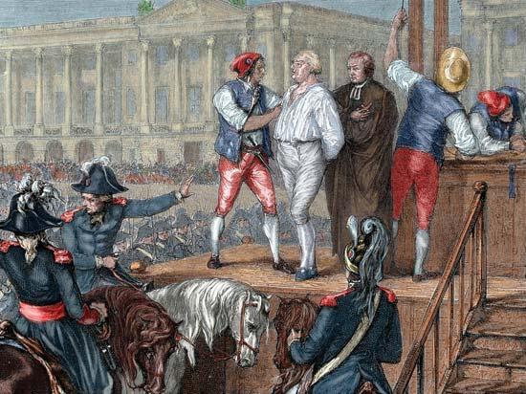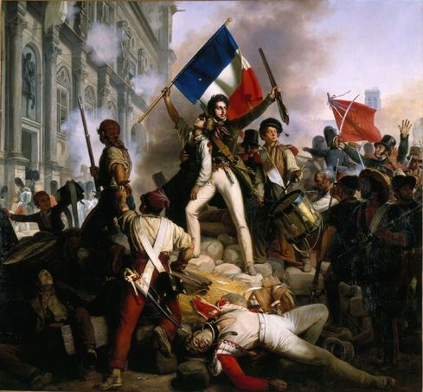

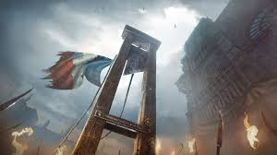

HOBBES Leviathan
LOCKE 2 Treatise of Government
ROUSSEAU Social Contract

SMITH Wealth of Nations

BECARRIA On Crimes and Punishment
MONTESQUIEU Spirit of the Laws

VOLTAIRE Candide
CONDORCET Sketch……..Human Progress

MILL On Liberty

KANT Critique of Pure Reason

BURKE Reflections on the Revolution inFrance

