**CANADA’S NEW FLAG – FEBRUARY 15, 1965**

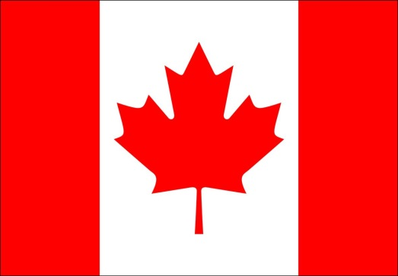 **vs** 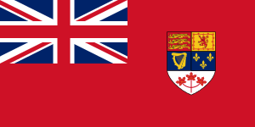

1. Who first suggested Canada should have its own flag? ________________________________________________________________________
2. What did the old flag feature? ________________________________________________________________________
3. Who designed the new flag? ____________________________________________
4. What 2 features did the designer say a new flag should have/be?

(In Figure 13-18 Quote)

_____________________________________________________________________

|  |  |
| --- | --- |
| **REASONS FOR CANADA KEEPING THE OLD FLAG** | **REASONS FOR CANADA CREATING A NEW FLAG** |
|  |  |

***YOU WILL BE RESPONSIBLE FOR SUMMARIZING THE SHEETS HANDED OUT ON 1) THE OCTOBER CRISIS AND 2) RESIDENTIAL SCHOOLS***

Summarize the following pages:

* October Crisis – 418-422 (only text)
* Residential Schools – 228-231

MINIMUM – 6 diverse sources

Chicago format – Chicago manual of style online



BOOK

* TITLE
* AUTHOR/S
* PUBLISHER
* CITY
* YEAR
  + PG #S

