Mr. Reynolds

**MINORITY REPORT OAKES TEST**

A major factor that plays into our Canadian Charter of Rights and Freedoms is the ‘reasonable limits’ clause. Pretty much our rights and freedoms are guaranteed in Canada **to a reasonable limit.** In light of what we’ve learned about the process to determine those limits (our Oakes Test), and with the help of a very popular movie (Minority Report), we will take on a few roles to further our understanding of our rights/freedoms and their limits.

1) Citizen of Canada - Outline 3 aspects within the movie *Minority Report* that are clear violations of your Charter Rights and Freedoms. (Give details from the movie **AND** the exact section, number, and wording from the Charter to show you fully understand.)

2) Supreme Court Judge - Choose 1 of the above 3 violations and complete a proper Oakes Test to determine if the Pre-Crime system’s violation of this right/freedom is reasonable in our society.

(Note – If you fail the test at any stage, regardless of the fact that the test should not continue, YOU WILL CONTINUE)

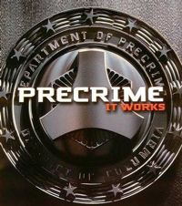

1. ***Sufficient Importance***
   1. ***What is the Objective of the Law***



* 1. ***Is it pressing and substantial***

1. ***Rational Connection***
   1. ***Between the Law and the Objective***
2. ***Minimal Impairment***
   1. ***To the Right/Freedom***
3. ***Detriment vs Benefit***