**ENGINEERING AN EMPIRE: GREECE**

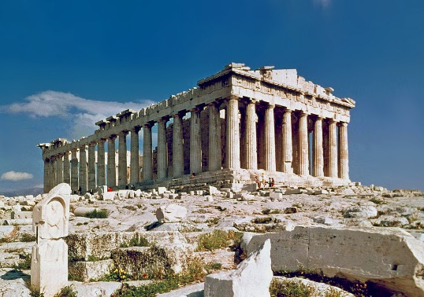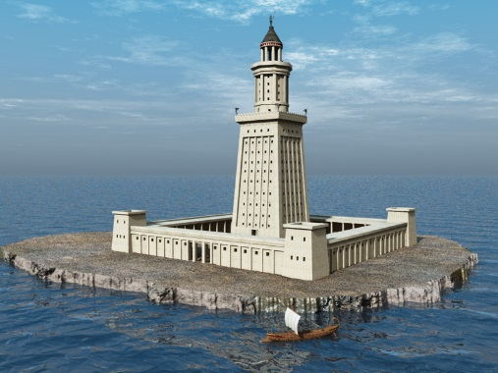

**Early Greek Civilization**

1. What group of people inhabited large portions of mainland Greece in 1300 BCE? Who led these people in their capital (map still at 11:13)?

2. What was the Iliad, and who wrote it? What was its role in early Greek society??

3. What was the Lion’s Gate, and what did it portray for Mycenae? What architectural building technique did this structure introduce, and what did this later evolve into to build the tholos?

**The Parthenon**

1. What was the Parthenon’s main function?

2. Why did many Athenians, including Plato, dislike the Parthenon?

3. Identify **at least 3** interesting construction concepts related to the Parthenon.

**Introduction: Philip II**

1. In 359 BCE, what 23 year old from the remote northern Greek region of Macedonia became king?

2. What is a phalanx?

3. What is a sarissa and how did the Macedonian army use it?

4. When fired, the oxbeles could pierce the shields and armor of an enemy at a _________ _______ away.

5. What did the Greeks call the crossbow?

6. Philip did not want to destroy Greece, he wanted to _____ ____________.

7. Who killed Philip II?

**Ptolemy I**

1. How did Ptolemy ensure his legitimacy both as Egypt’s king and the true heir to Alexander?

2. Ptolemy ordered what engineering project for Alexandria’s harbor?

3. Identify some interesting construction concepts related to the site.

4. What happened to this structure around 1300CE?

5. What was the second engineering project that Ptolemy started?

6. What Egyptian practice did Ptolemy son, Ptolemy II embrace as an “Egyptian Pharaoh”?

**Hero of Alexandria**

23. What happened to Ptolemy before his two structures were finally completed?

24. Hero experiments with __________ technology that would ignite his imagination.

25. What happened to the Library at Alexandria?

26. Greece was not to be extinguished, it was absorbed by what many believe was the greatest experiment in Hellenism of all, _______________________________________.

1. Oldest 2 Greek Civilizations (Bronze Age)
   1. Minoans
   2. Mycenaeans
2. 3 Geographic features of Greece
   1. Surrounded by water (Aegean Sea)
   2. Lots of mountains
   3. Lots of islands
   4. Few connecting rivers/sparse soil

POLIS!!! – city state

1. What is the name of the innovation that led to democracy in Athens (BOTH terms)
   1. Hoplites
   2. Phalanx
2. Legal code of ATHENS – Draco
3. SPARTA – Lycurgus
4. Name ONE of the 2 major democracy innovators in Athens
   1. Solon
   2. Cleisthenes
5. Name of the Spartan education system
   1. Agoge
6. Name of the Spartan rulers that could overrule the Council (there are 5…hint hint)
   1. Ephors
7. Name the first battle during the Persian Wars
   1. Marathon
8. Who lost the battle of Thermopolyae?
   1. Sparta
9. How was the battle of Salamis fought?
   1. Triremes (boats)
10. What 2 city-states did Athens screw with to start the Peloponnesian war?
    1. Corinth & Megara
11. What were the Spartan and Athenian “Leagues” called?
    1. Athens – Delian
    2. Sparta – Peloponnesian
12. Who was the initial leader for Athens? Give 1 of his big plans?
    1. Pericles
       * Long Wall
       * Raid by sea
13. Who took over? Why did he SUCK??
    1. Alcabides
       * Fight on land
       * Wanted to capture Syracuse
14. Identify 2 results of the Peloponnesian war.
    1. Fleet gone (down to 12)
    2. Exiles forced back into city
    3. 30 Tyrants
    4. Long wall gone

LOSES WORLD STANDING

PHILIP II – Macedonian King takes over Greece!!



Philip invents the sarissa (longer spear)

Alexander

* Tutored by Aristotle & trained by his father in military
* Ambition to conquer Persia (w/ 35000 soldiers)



* Alexander had loyal generals (Darius NOT)



* Gaugamela – MAJOR battle where it all came down for Darius



* Went as far as indus river in india



* Greek culture and language the unifying force



* Allowed local customs & laws to remain (BRILLIANT)
* Greek cities became template EVERYWHERE!!!