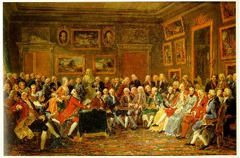

CHY4U: THE ENLIGHTENED ENLIGHTENMENT ASSIGNMENT

You are invited a Salon to express your thoughts, opinions, and intellectual ideas on issues important to the intellectual climate of Europe.

OBJECTIVE: In pairs, students will research an assigned enlighten thinker/philosopher/character and deliver your findings to the rest of the class in a brief presentation. You will also be responsible for providing the class with a handout (1 Page, 2 Side!!!) which summarizes the required information.

SUCCESS CRITERIA: RESEARCHING YOUR INDIVIDUAL
Your presentation and handout must include the following information:

- Biographical Information – Full name, Birth/Death, Country or Origin, Key Dates, Area of Study (Political, Social, Legal, Cultural, Intellectual)

- Enlightened Idea/s – A clear and concise summary of your individual’s idea using the following outline:
- The major work they introduced (usually a book/essay)
- What the topic of the work is
- What they argue/conclude about the topic
- Primary Source Quotes that outline the argument (3-4)
- An explanation of the quotes

- How the individual was viewed BOTH then and now (Secondary Sources)

- The impact their work had BOTH then and now (Secondary Sources)
A WORD OF ADVICE……
Please understand that this is designed to be an IN CLASS, GROUP assignment. I am giving you several full work periods for a reason. Use your time in class effectively and there will be little need to complete additional work outside of class.
Choosing to split up the work for the entire assignment defeats the purpose and often leads to disastrous results. BOTH of you need to know your individual backwards and forwards!!

CREATING YOUR HANDOUT
Your handout must:
  - Clearly summarize your research findings IN YOUR WORDS!!
  - Be logically organized, using subheadings, arrows
  - Bullet points are encourage, though not too brief
  - COMPLETE LIST OF SOURCES (IN CHICAGO STYLE), NUMBERED!!
  - Must be submitted PRIOR to Salon (so I can photocopy it!!)

PRESENTATION
The Salon was not much different than the modern day coffee shop. It was a place where men and women came together to exchange their views on politics, literature, art and a wide range of other subjects. You are simply invited to a Salon to speak intelligently about your individual; in essence, you are representing them at the Salon to aid in the intellectual development of our class.

Your presentation must:
- Include all group members who will confidently indicate their understanding of the subject material
- BRIEFLY cover all required research components (No more than 5-6 minutes)
- You MUST provide your personal opinion on their work and be able to answer a question or 2

FOR THE LOVE……PAY ATTENTION TO THE RUBRIC!!!!!!

