**CHC2P CULMINATING ACTIVITY:**

**20TH CENTURY CANADA TIMELINE**

**LEARNING GOAL:** For students to evaluate 20th Century Canadian events and determine whether it was a century of *progress* or *decline.*

**TASK:** Students will create a timeline highlighting the **TOP 10** events in the past 100 years of Canadian history. The steps on this project are:



1) Select your personal top 10 Canadian events of the past 100 years

2) Write a small (2-3 Sentence) blurb on **WHAT HAPPENED** during that event (just what happened…not bigger picture stuff) and determine whether it was a move forward for Canada (PROGRESS) or a move backwards (DECLINE)



3) Make a timeline that:

a) Shows the chronological order of your events (Year)

b) Shows the progression/decline over time (positive/negative for Canada)

c) Has images that reflect what happened (pretty it up)

d) COLOUR CODE your events based on themes (War, Human Rights, Politics)

4) Write 3 small paragraphs on your top 3 moments for 20th Century Canadian History. Focus these paragraphs on what makes these moments so significant that they are the most important.

- These events should be VERY important for the development of Canadian identity (makes us who we are)

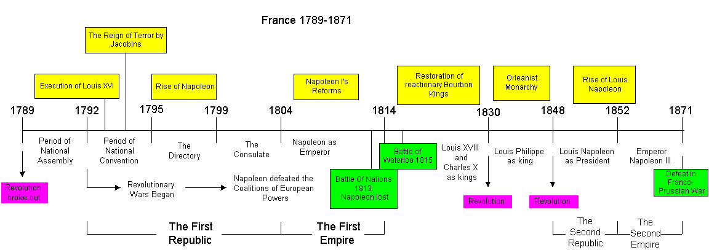



YPRES

VIMY RIDGE

CONSCRIPTION

WOMEN IN THE WORKPLACE

WAR MEASURES ACT

RESIDENTIAL SCHOOLS



TREATMENT OF ENEMY ALIENS WWI



LEAGUE OF NATIONS

WINNIPEG GENERAL STRIKE

PERSONS CASE

STATUTE OF WESTMINSTER

ON TO OTTAWA TREK / CAMPS

BENNETT’S ASSISTANCE PLAN

DIEPPE

JUNO BEACH (D-DAY)

JAPANESE CANADIANS

\

NEWFOUNDLAND JOINS

QUIET REVOLUTION



(FLQ TERRORISM) – OCTOBER CRISIS

ST. LAWRENCE SEAWAY OPENS

NEW FLAG



AVRO ARROW

CANADA COUNCIL

LEGAL CHANGES – LOTS!!

MEDICARE



BILL OF RIGHTS



TRANS CANADA HWY

72’ SUMMIT SERIES



1) PICK YOUR TOP 10

2) MAKE CATEGORIES

- Battles, International Conflict, War

- Independence, Human Rights,

- Political/Legal Decisions

- Human Rights/ Social Rights / Internal Conflict

3) PUT THEM IN ORDER!!!!

Statute



Flag



League of nations



During 20th century conflicts the Canadian government did bad things.

* WWI – Germans
* WWII – J.C.



* October Crisis – Quebecers



WAS THE CANADIAN GOVERNMENT



MISTREATING MINORITY GROUPS



DURING 20TH CENTURY CONFLICTS?

