Mr. Reynolds
CANADA’S CONTRIBUTIONS TO WWI
Answer the following questions using the Creating Canada textbook (PG. 181 – 185)

The War at Sea – PG 181
Direct Questions
1) Why were ships so essential to both sides during WWI? __________________
____________________________________________________________________________________________________________________________

2) What weapon did the Germans have that gave them a slight advantage? ______________________________________________________________

3) How did the Allies counter the German tactic? _________________________
____________________________________________________________________________________________________________________________

4a) What act potentially helped get America to join WWI? _________________
_____________________________________________________________

b) Why is this act only considered to “potentially” have helped? ______________
____________________________________________________________________________________________________________________________

Critical Question
1) WWI helped speed the growth of the Canadian navy from 2 ships to 100. Is this change a positive one for Canada or a negative? EXPLAIN!!
______________________________________________________________________________________________________________________________________________________________________________________________________________________________________________________________________________________________________________________
______________________________________________________________

The War in the Air - PG 181
Direct Questions
1) How did Canadian pilots join WWI when Canada had no air force? ___________
______________________________________________________________
2) What missions were planes given in WWI? ____________________________
______________________________________________________________

3a) What did it take to be an ace? ____________________________________
b) Who was Canada’s top ace? ______________________________________
c) Why was becoming an ace such a difficult thing to do? (Read CONNECTIONS) __________________________________________________________________________________________________________________________________________________________________________________________

Critical Question
1) Would it be wrong of the Canadian government to withhold information on the life expectancy of pilots during WWI from the public and would-be pilots? Why/Why not? __________________________________________________________________________________________________________________________________________________________________________________________

A New Kind of War – PG 182
Direct Questions
1) Where & when was Canada’s first contribution to WWI made? ______________________________________________________________

2) What did the Germans use as a weapon there? Describe its effects. __________________________________________________________________________________________________________________________________________________________________________________________

Critical Questions
1) Would you consider Canada’s contribution to the fighting at Ypres a success or not? Why?______________________________________________________
______________________________________________________________

2) The use of poison gas in warfare was banned by international agreement in 1925? Does setting rules for waging war make sense? __________________________________________________________________________________________________________________________________________________________________________________________
The Battle of the Somme
Direct Questions
1) What was Douglas Haig’s goal during this battle? ____________________________________________________________________________________________________________________________

2) Using the Newfoundland Regiment as proof, why was not taking out the barbed wire such a costly mistake? _________________________________________
____________________________________________________________________________________________________________________________

Critical Questions
1) Read the last paragraph – Was Haig a good General? Why/why not? ______________________________________________________________________________________________________________________________________________________________________________________________________________________________________________________________________________________________________________________

2) What might this battle have done to Canadian attitudes towards British commanders? ___________________________________________________
____________________________________________________________________________________________________________________________

The Battle of Vimy Ridge – PG 183 https://www.youtube.com/watch?v=FMJ_yjchLrc
Direct Questions
1) Why was Vimy Ridge such an important location to have? __________________
______________________________________________________________

2) What was the unique factor about this battle that had never happened before for the Canadians? _______________________________________________

3) Who was the Canadian commander? _________________________________

4) Explain the ‘creeping barrage.’ _____________________________________
____________________________________________________________________________________________________________________________
5) What tactics did Currie use before the battle that had never been used before? ________________________________________________________________________________________________________________________________________________________________________________________________________________________________________________________
____________________________________________________________________________________________________________________________

6) What evidence is there that suggests France was eternally grateful to Canada for the victory at Vimy Ridge? _______________________________________
____________________________________________________________________________________________________________________________

Critical Questions – PG 184
1) Why is Vimy Ridge seen as a turning point in Canada’s history? __________________________________________________________________________________________________________________________________________________________________________________________

2) Read the REMEMBERING VIMY story. Is a monument like the Vimy Memorial an appropriate way to remember those who died during WWI? Or are there more modern ways for us to remember important events? ________________________________________________________________________________________________________________________________________________________________________________________________________________________________________________________________________________________________________________________________________________________________________________________________________________________________________________________________________________________________________________

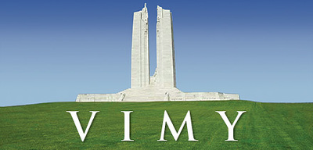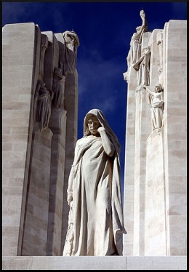
The Battle of Passchendaele – PG 185
Direct Questions
1) Describe what the Passchendaele landscape was like. ____________________
____________________________________________________________________________________________________________________________

2) What did Currie do during Passchendaele that was similar the Vimy? __________________________________________________________________________________________________________________________________________________________________________________________

Critical Questions
1) After reading about JUST the # dead, was this an important mission? ______________________________________________________________

2) After reading about JUST the ground gained, was this battle worth the number lost? __________________________________________________________
____________________________________________________________________________________________________________________________

3) If MANY WWI battles were like this, how do you think you would feel if you were a soldier who had fought for 4 years in WWI? BE DETAILED IN WHY YOU WOULD FEEL THIS WAY – pretend to be a soldier…write what they would.
__________________________________________________________________________________________________________________________________________________________________________________________________________________________________________________________________________________________________________________________________________________________________________________________________________________________________________________________________________________________________________________________________________________________________________________________________________________________________________________________________________________________________________

